GreenIT Application Challenge

# Front-end Software used

Angular CLI – Version 14.2.3

# Back-end Requirements Software used

PHP – Version 8.1.10

Screen Snaps

## Home Screen - List Order

Table designed with Angular Material

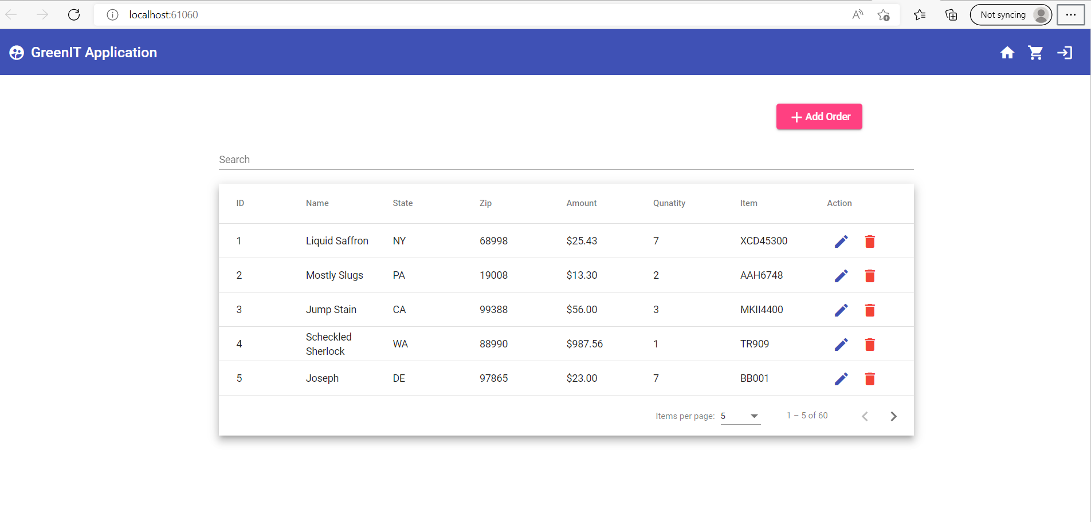

## Add Order

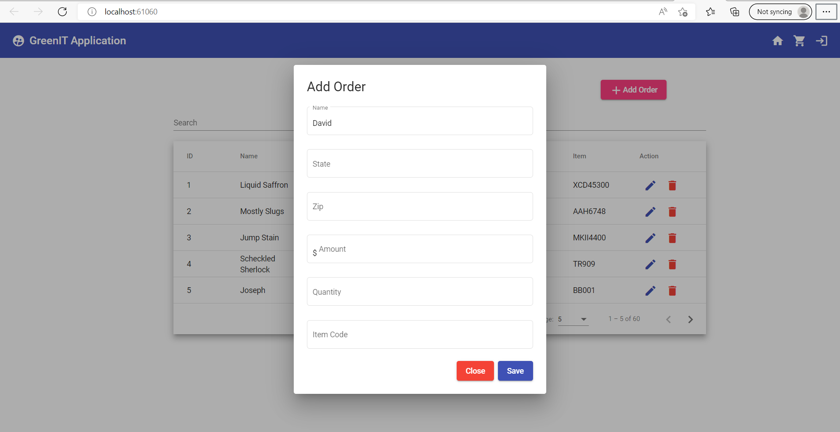

## Add Order - Validations

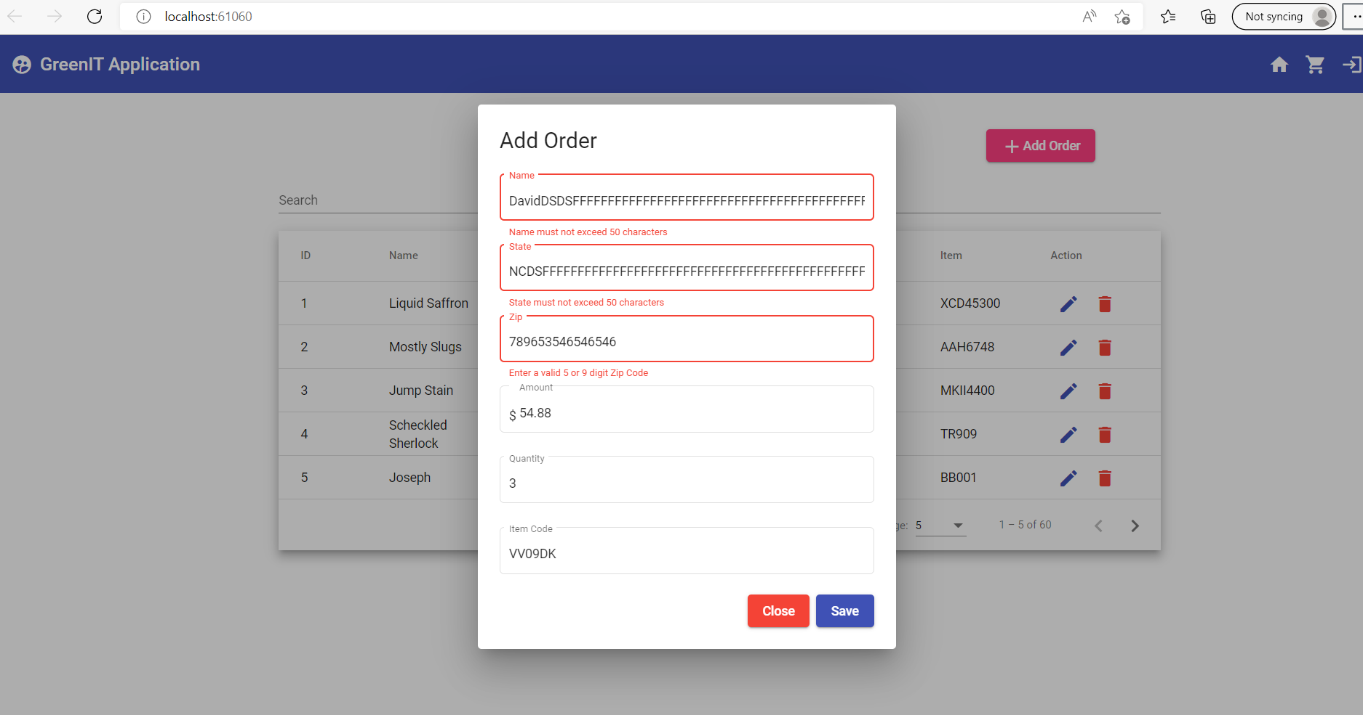

## Delete Order

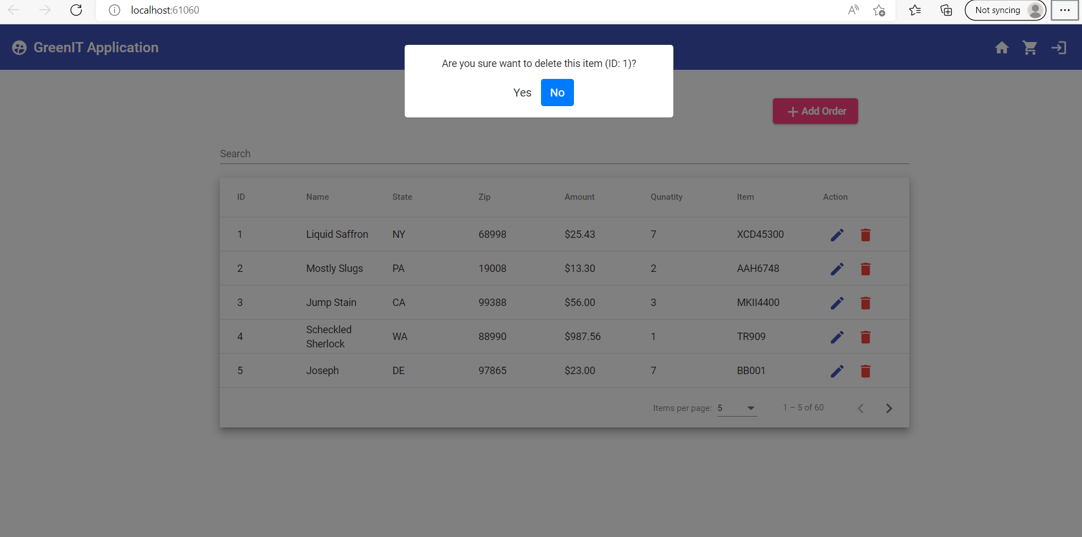

Docker Deployment – Front end

